|  |  |  |  |  |  |  |
| --- | --- | --- | --- | --- | --- | --- |
|  | N | Mean | Median | Min | Max | SD |
| Group1 | 17 | 28.47 | 29 | 15 | 42 | 8.62 |
| Group2 | 92 | 30.95 | 30.5 | 3 | 46 | 7.48 |
| Group3 | 34 | 28.88 | 28 | 17 | 44 | 6.20 |

Total score distribution by groups

Q4

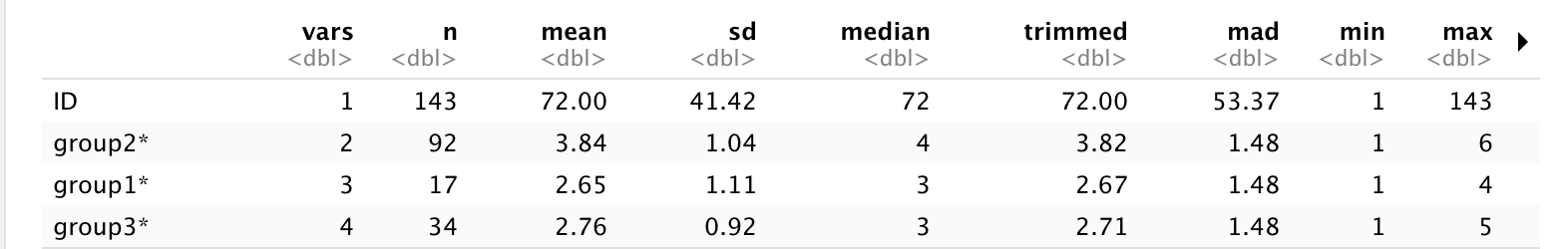

Q5

Q6

Q7

Q8

Q9

Q10

Q11

Q12

Q13

Distribution by race

|  |  |  |
| --- | --- | --- |
|  | white | Non-white |
| Group1 | 16 | 2 |
| Group2 | 89 | 8 |
| Group3 | 30 | 4 |

Distribution by age

Distribution by gender

|  |  |  |
| --- | --- | --- |
|  | male | female |
| Group1 | 16 | 3 |
| Group2 | 88 | 39 |
| Group3 | 30 | 8 |

Distribution by Hispanic race

|  |  |  |
| --- | --- | --- |
|  | Hispanic | Non-hispanic |
| Group1 | 16 | 4 |
| Group2 | 88 | 36 |
| Group3 | 30 | 10 |